

CO3 ASSESSMENT TOOL 1 – GIT & DOCKER TECHNICAL ASSIGNMENT

CSA1012
SOFTWARE ENGINEERING

Project: SmartCare Assets — Intelligent Hospital Asset Tracking
and Equipment Management Platform

Field | Details
Course Code | CSA1012
Course Title | Software Engineering
CO Assessed | CO3 – Build full-stack applications with an emphasis on containerization, version control, and collaborative development
Assessment | Assessment Tool 1 – Git & Docker Technical Assignment
Student Name | Ashwin S
Register No. | 192311410
Date | August 2026

1. Problem Analysis

1.1 Assigned Problem Statement
The assigned project, SmartCare Assets, is an intelligent hospital asset-tracking and equipment-management platform. Hospitals manage thousands of shared, mobile medical assets — ventilators, infusion pumps, ECG machines, and portable monitors — that move continuously between departments. Manual registers and periodic audits cannot keep pace with this movement, so clinical staff routinely waste time searching for equipment, and maintenance is discovered reactively rather than predicted in advance. This assignment applies Git version control and Docker containerization practices to the backend service that powers this platform: a FastAPI application exposing asset-registration, battery-telemetry, and search endpoints, backed by a PostgreSQL database.

1.2 Project Objectives
- Track the real-time location and status of tagged hospital equipment.
- Ingest battery/telemetry data and flag low-battery or maintenance-required conditions automatically.
- Expose a versioned, testable REST API that other modules (dashboards, alerting) can build on.
- Package the service so it can be deployed consistently across development, staging, and production using containers.
- Maintain a clean, auditable version history that supports collaborative development by multiple contributors.

1.3 Functional Requirements
- Register a new asset with a unique asset code and tracking device ID (reject duplicate tracking IDs).
- Search registered assets by code or equipment type.
- Ingest telemetry (battery level, location) for a given tracking ID and update the asset's live status.
- Automatically flag an asset as Maintenance Required when its battery drops below a configured threshold.
- Expose a health-check endpoint for container orchestration and monitoring.

1.4 Expected Outcomes
A containerized, version-controlled backend service that a hospital IT team could deploy with a single `docker compose up` command, with a Git history that clearly documents how the asset-registration, telemetry, and containerization features were built, merged, released, and hot-fixed — providing both a working artifact and a maintainable development record.
2. Project Structure Design

2.1 Repository Folder Structure
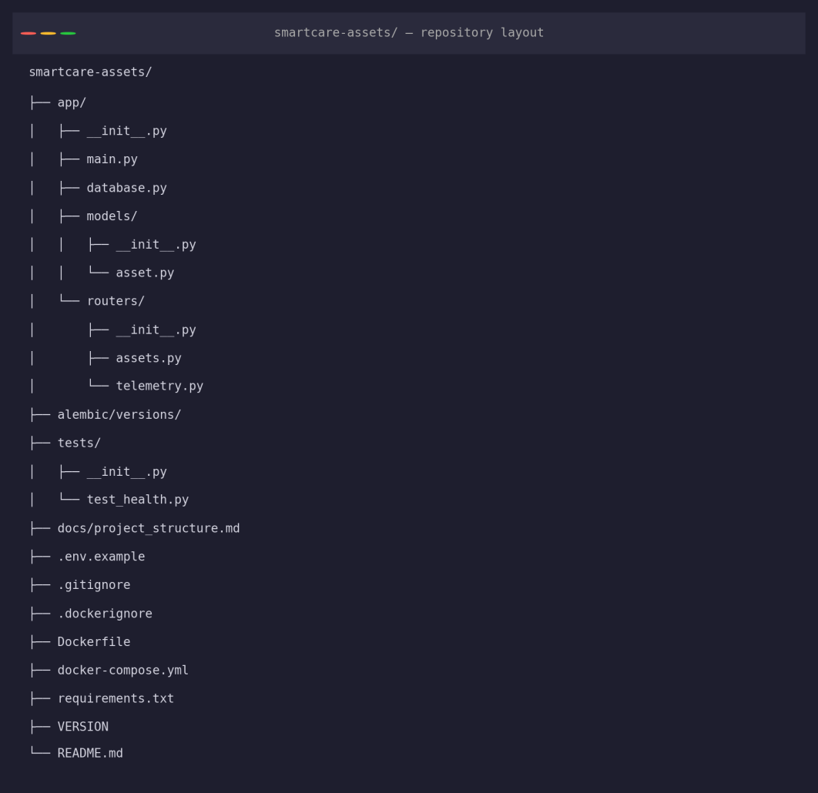
Figure 1: Repository folder structure

2.2 Purpose of Major Folders and Files
app/: all application source code. Kept as a Python package (contains __init__.py) so it can be imported cleanly by tests and by Uvicorn.
app/models/: SQLAlchemy ORM classes (asset.py defines the Asset table and AssetStatus enum). Separated from route logic so the data layer can be tested and reused independently of the API layer.
app/routers/: FastAPI routers grouped by feature area — assets.py (registration/search) and telemetry.py (battery ingestion) — rather than one large file, supporting modularity as more features are added.
alembic/versions/: reserved for version-controlled database schema migrations, so schema changes are tracked and reproducible across environments rather than applied by hand.
tests/: automated Pytest suite, mirroring the app package layout.
docs/project_structure.md: living documentation of the repository layout and rationale, kept in-repo so it stays versioned alongside the code it describes.
.env.example: documents required environment variables without committing real credentials; the actual .env file is excluded via .gitignore.
Dockerfile / docker-compose.yml / .dockerignore: containerization definitions, described in detail in Sections 7–9.
requirements.txt: pinned Python dependencies, ensuring the same package versions are installed in every environment (developer machine, CI, container).
3. Git Repository Initialization

3.1 Initialization Steps
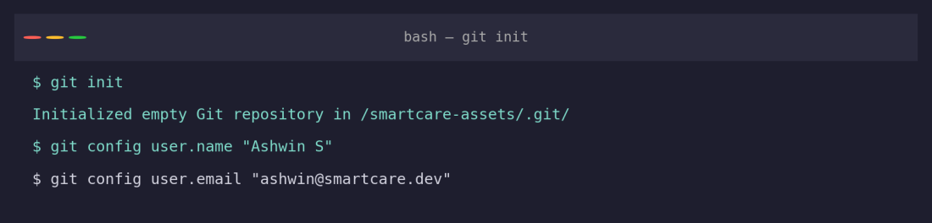
Figure 2: Repository initialization and identity configuration
The repository was initialized with `git init`, and a local user identity was configured with `git config` so that commits carry the correct author information. The first commit added the project scaffold — the FastAPI app, the Asset model, and the registration/search endpoints — establishing a clean baseline before any feature branching began.
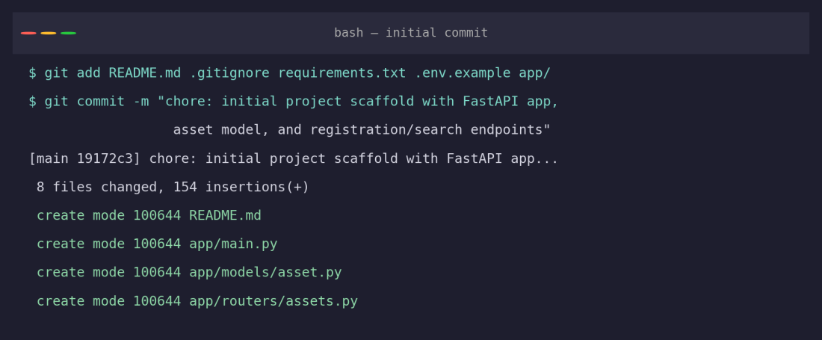
Figure 3: Initial commit adding the project scaffold

3.2 Purpose of Essential Git Files
.git/: the hidden directory created by `git init` that stores the entire object database, commit history, branches, and configuration — this is what makes the folder a Git repository.
.gitignore: tells Git which files/folders to never track (virtual environments, __pycache__, .env, logs), keeping the repository free of machine-specific or sensitive files.
.git/config: stores repository-local settings, including the user.name/user.email identity used for commit authorship shown above.
4. Git Branching Strategy

4.1 Selected Branching Model
This project uses a Git Flow-inspired branching model with five branch types: Main, Develop, Feature, Release, and Hotfix.
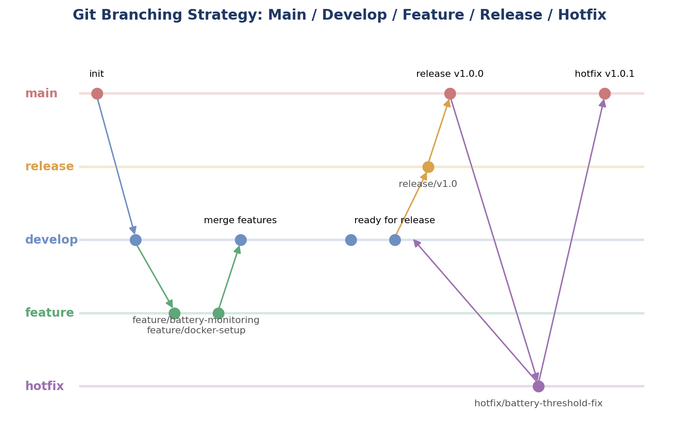
Figure 4: Branching strategy — Main / Develop / Feature / Release / Hotfix
main: always reflects the latest stable, released code (tagged v1.0.0, v1.0.1). Nothing is committed to main directly.
develop: the integration branch where completed features are merged and tested together before a release is cut.
feature/*: one branch per feature (feature/battery-monitoring, feature/docker-setup, feature/api-docs), branched from develop and merged back into develop once complete.
release/*: a short-lived branch (release/v1.0) cut from develop to prepare a release — version bump, final checks — then merged into main and tagged.
hotfix/*: branched directly from main to urgently patch a production issue (hotfix/battery-threshold-fix), then merged into both main and develop so the fix is never lost on the next release.

4.2 Why This Model Suits This Project
SmartCare Assets is a small backend service developed by a single contributor but designed to be deployed to a live hospital environment, where an unstable main branch is unacceptable. Git Flow's strict separation between main (always deployable) and develop (integration in progress) matches this constraint well. Feature branches let each capability — telemetry ingestion, containerization, documentation — be built and reviewed in isolation, and the explicit hotfix path matters specifically because a bug in the low-battery alert threshold is the kind of defect that needs a fast, isolated fix reaching production without waiting for the next full release cycle.
5. Version Control Workflow

5.1 Branch Creation and Feature Development
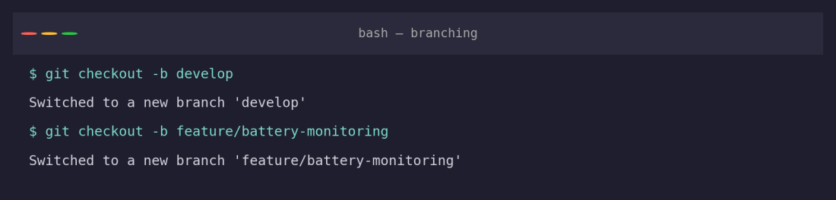
Figure 5: Creating the develop branch and a feature branch
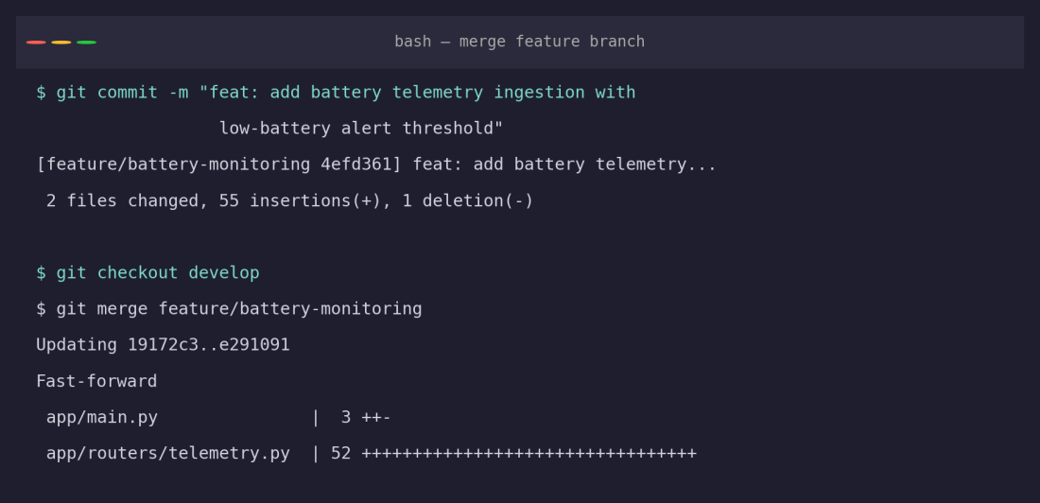
Figure 6: Committing the feature and fast-forward merging into develop
The battery-monitoring feature was committed on its own branch and merged into develop with a fast-forward merge, since develop had not advanced in the meantime. This is the simplest merge outcome and is appropriate for small, self-contained features merged shortly after they branch.

5.2 Conflict Resolution
Two branches — feature/docker-setup and feature/api-docs — were both branched from develop and both edited the same paragraph of README.md (one adding a note about the Docker healthcheck, the other adding Swagger/ReDoc documentation links). Merging the first branch succeeded cleanly; merging the second produced a genuine conflict:
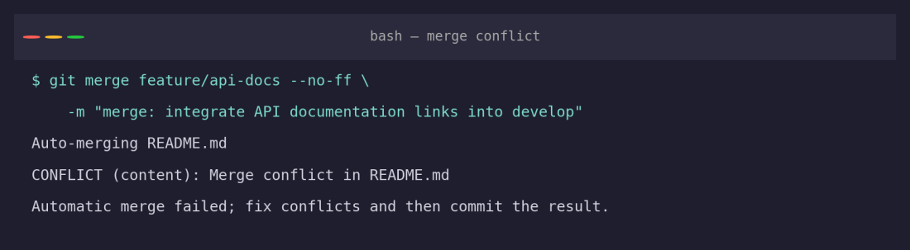
Figure 7: Merge conflict reported by Git
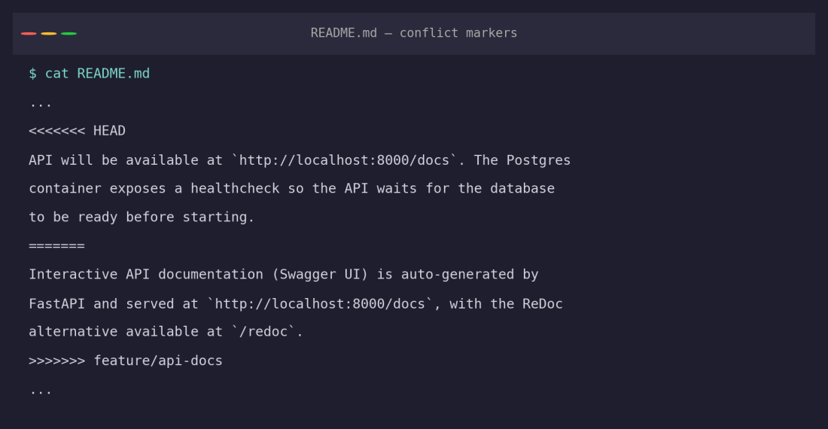
Figure 8: Conflict markers left in README.md for manual resolution
The conflict was resolved by manually editing README.md to keep both pieces of information — the Docker healthcheck note and the Swagger/ReDoc links — rather than discarding either side, then staging the resolved file and committing the merge:
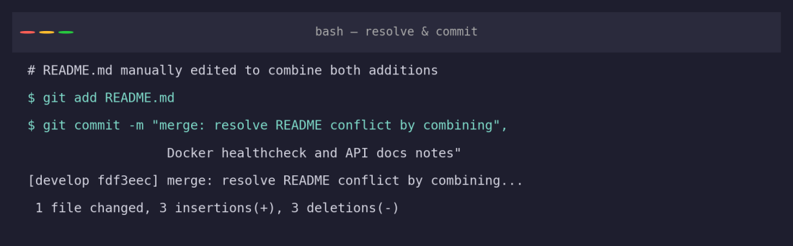
Figure 9: Conflict resolved, staged, and committed

5.3 Release and Hotfix Workflow
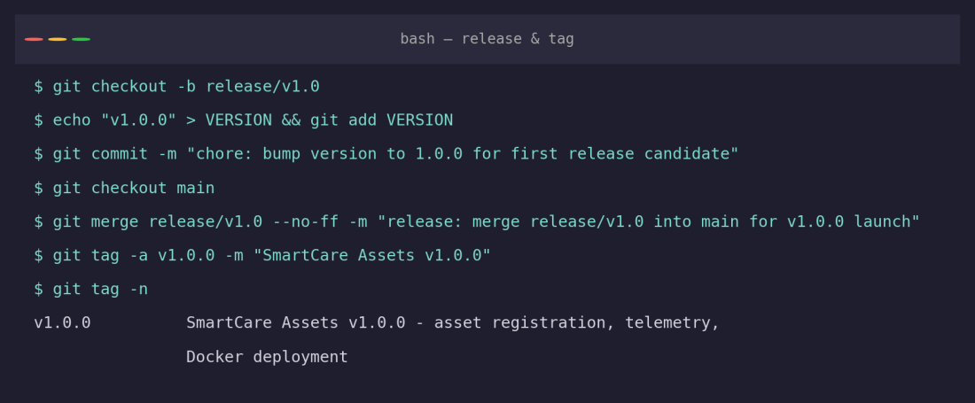
Figure 10: Cutting release/v1.0, merging into main, and tagging v1.0.0
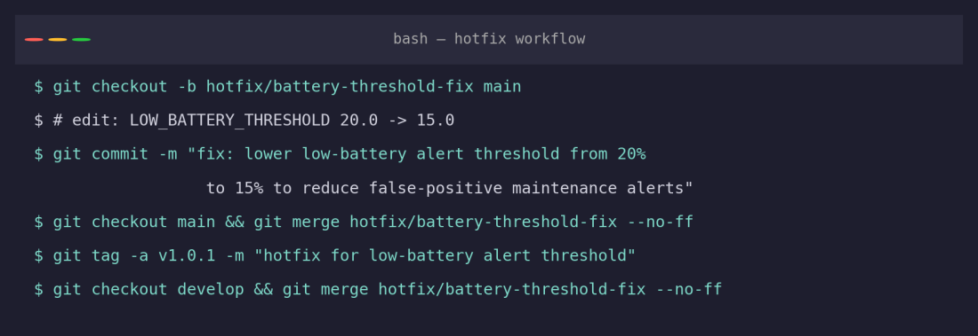
Figure 11: Hotfix branched from main, merged into both main and develop, tagged v1.0.1

5.4 Purpose of Each Git Operation
git checkout -b: creates and switches to a new branch, isolating in-progress work from the stable branch it was cut from.
git merge (fast-forward): moves the target branch pointer forward when no divergent commits exist — the simplest, history-preserving integration.
git merge --no-ff: forces a merge commit even when a fast-forward is possible, preserving a visible record that a feature/release/hotfix branch existed and was integrated — used here for all Develop/Main integrations.
git tag -a: creates an annotated, permanent marker on a specific commit (v1.0.0, v1.0.1), used to mark exactly what code was released.
Conflict resolution: manual editing of conflict-marked sections followed by `git add` and `git commit`, used when Git cannot automatically reconcile two divergent edits to the same lines.
6. Commit History Analysis

6.1 Full Commit Graph
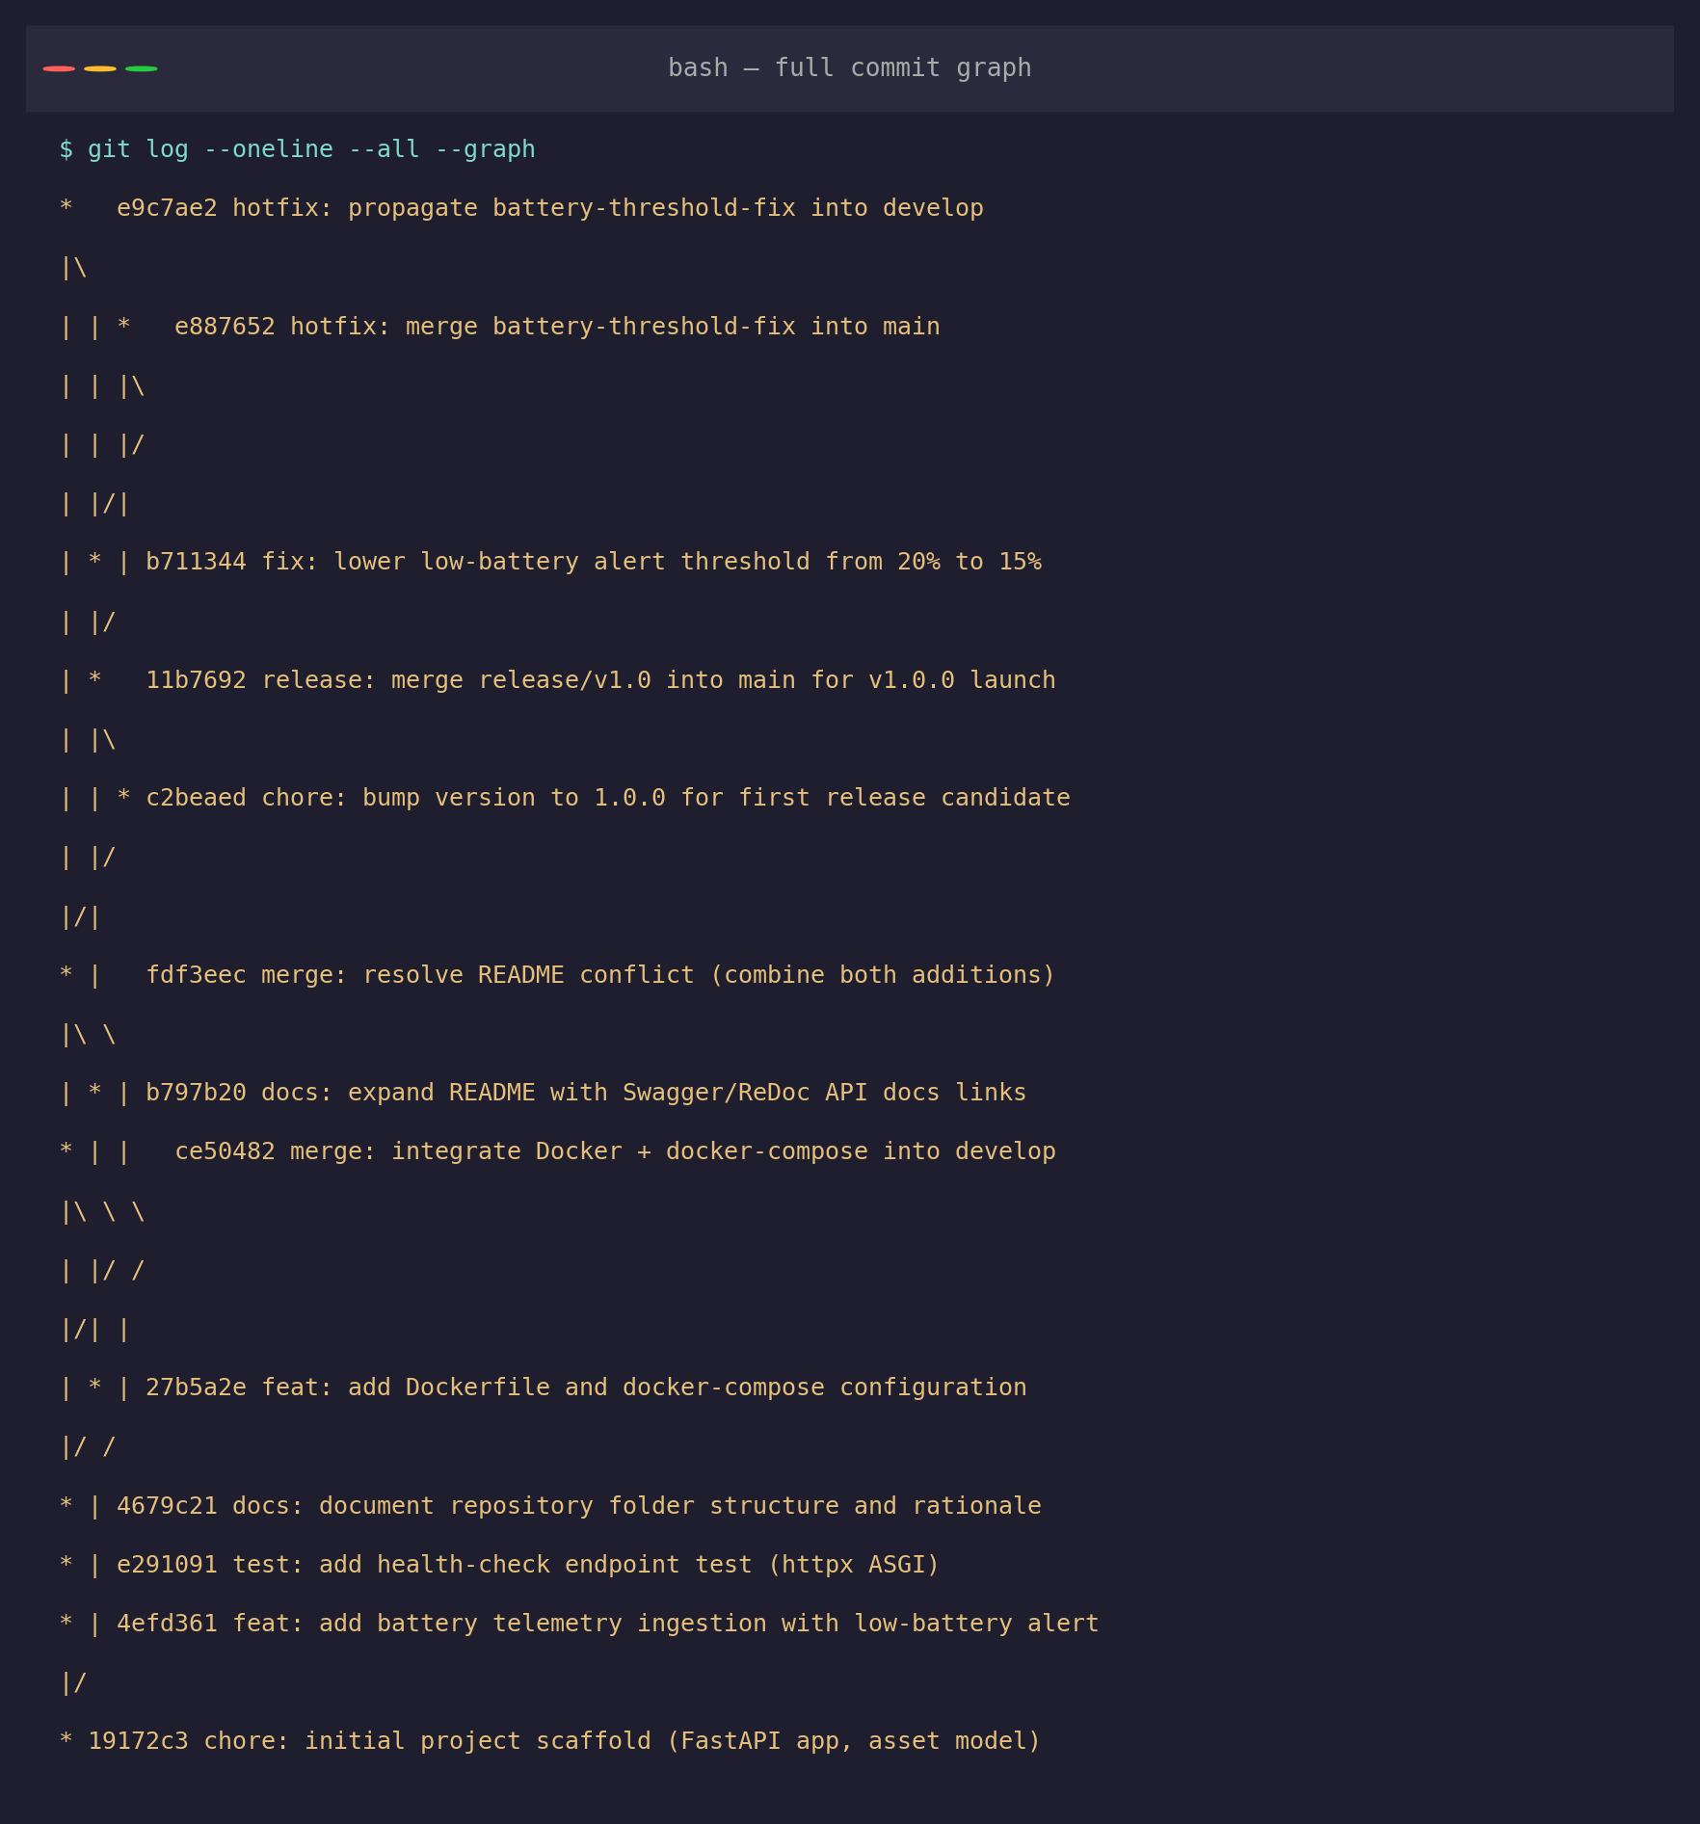
Figure 12: Complete commit history across all branches (git log --oneline --all --graph)
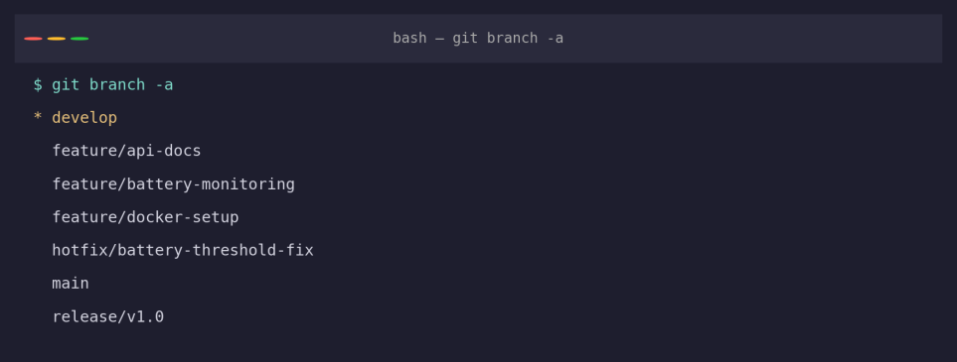
Figure 13: All branches present in the repository

6.2 Commit Message Conventions
Every commit in this history follows a Conventional-Commits-style prefix (feat:, fix:, docs:, test:, chore:, merge:, release:, hotfix:) followed by a concise, imperative summary of what changed and, where useful, why. For example, fix: lower low-battery alert threshold from 20% to 15% to reduce false-positive maintenance alerts states the change and its motivation in one line, without needing to open the diff to understand intent.

6.3 How This Contributes to Project Maintenance
- The prefix taxonomy (feat/fix/docs/test/chore) lets a reviewer scan `git log --oneline` and immediately classify each change without reading the diff.
- Merge and release commits are explicitly labelled (merge:, release:, hotfix:), making the graph in Figure 12 self-documenting about which branches were integrated and when.
- Annotated tags (v1.0.0, v1.0.1) give a permanent, unambiguous reference point for “what was actually deployed,” which matters for a hospital-facing system where rollback and audit trails are operationally important.
- Small, single-purpose commits (one feature, one fix, one doc update per commit) mean `git bisect` or `git revert` can isolate a regression to a specific, narrow change rather than a large mixed commit.

7. Docker Environment Design

7.1 Why Docker Is Suitable for This Project
SmartCare Assets depends on a specific Python runtime, a set of pinned packages, and a PostgreSQL database — three moving parts that must match exactly between a developer's laptop, a CI pipeline, and a hospital's production server. Docker removes “works on my machine” failure modes by packaging the application and its exact runtime into an image that behaves identically everywhere it runs, and Docker Compose lets the API and database be defined, networked, and started together with a single command — important for a small team (or solo developer) that needs to onboard or redeploy quickly without a manual setup checklist.

7.2 Components Requiring Containerization
- API service (smartcare-api): the FastAPI/Uvicorn application — containerized so its exact Python version and dependency set travel with it.
- Database service (smartcare-db): PostgreSQL 16 — containerized using the official postgres:16-alpine image so no manual database installation is required on any host.
- Network layer (smartcare-net): a private bridge network so the API and database can address each other by service name without exposing the database port to the host.
- Persistent volume (postgres_data): a named Docker volume so database contents survive container restarts and rebuilds.

8. Dockerfile Development

8.1 Dockerfile
FROM python:3.12-slim AS base
ENV PYTHONDONTWRITEBYTECODE=1 \
PYTHONUNBUFFERED=1
WORKDIR /app
COPY requirements.txt .
RUN pip install --no-cache-dir -r requirements.txt
COPY app/ ./app/
COPY alembic/ ./alembic/
RUN useradd --create-home appuser
USER appuser
EXPOSE 8000
HEALTHCHECK --interval=30s --timeout=5s --start-period=10s \
CMD python -c "import urllib.request; urllib.request.urlopen('http://localhost:8000/health')" || exit 1
CMD ["uvicorn", "app.main:app", "--host", "0.0.0.0", "--port", "8000"]

8.2 Purpose of Each Instruction
FROM python:3.12-slim: starts from a minimal official Python image — small enough for fast builds and a smaller attack surface than a full OS image.
ENV PYTHONDONTWRITEBYTECODE / PYTHONUNBUFFERED: stops Python writing .pyc files into the image layer and ensures logs are flushed immediately, which matters for container log visibility.
WORKDIR /app: sets a consistent working directory for all subsequent instructions and the running container.
COPY requirements.txt . + RUN pip install: installs dependencies in their own layer before copying application code, so Docker's build cache is reused (dependencies aren't reinstalled) whenever only application code changes.
COPY app/ / COPY alembic/: copies application source and migration scripts into the image after dependencies are cached.
RUN useradd + USER appuser: creates and switches to a non-root user — a security best practice so the container process does not run with root privileges.
EXPOSE 8000: documents which port the container listens on (informational; actual publishing happens in docker-compose.yml).
HEALTHCHECK: lets Docker (and docker-compose's depends_on: condition: service_healthy) know whether the API is actually ready to serve traffic, not just whether the process has started.
CMD: the default command run when the container starts — launches Uvicorn bound to all interfaces so it is reachable from outside the container.

9. Docker Compose Design

9.1 docker-compose.yml
version: "3.9"
services:
api:
build: .
container_name: smartcare-api
restart: unless-stopped
ports:
- "${API_PORT:-8000}:8000"
environment:
- DATABASE_URL=${DATABASE_URL}
depends_on:
db:
condition: service_healthy
networks:
- smartcare-net
db:
image: postgres:16-alpine
container_name: smartcare-db
restart: unless-stopped
environment:
- POSTGRES_USER=${POSTGRES_USER}
- POSTGRES_PASSWORD=${POSTGRES_PASSWORD}
- POSTGRES_DB=${POSTGRES_DB}
volumes:
- postgres_data:/var/lib/postgresql/data
healthcheck:
test: ["CMD-SHELL", "pg_isready -U ${POSTGRES_USER} -d ${POSTGRES_DB}"]
interval: 10s
timeout: 5s
retries: 5
networks:
- smartcare-net
volumes:
postgres_data:
networks:
smartcare-net:
driver: bridge

9.2 Architecture
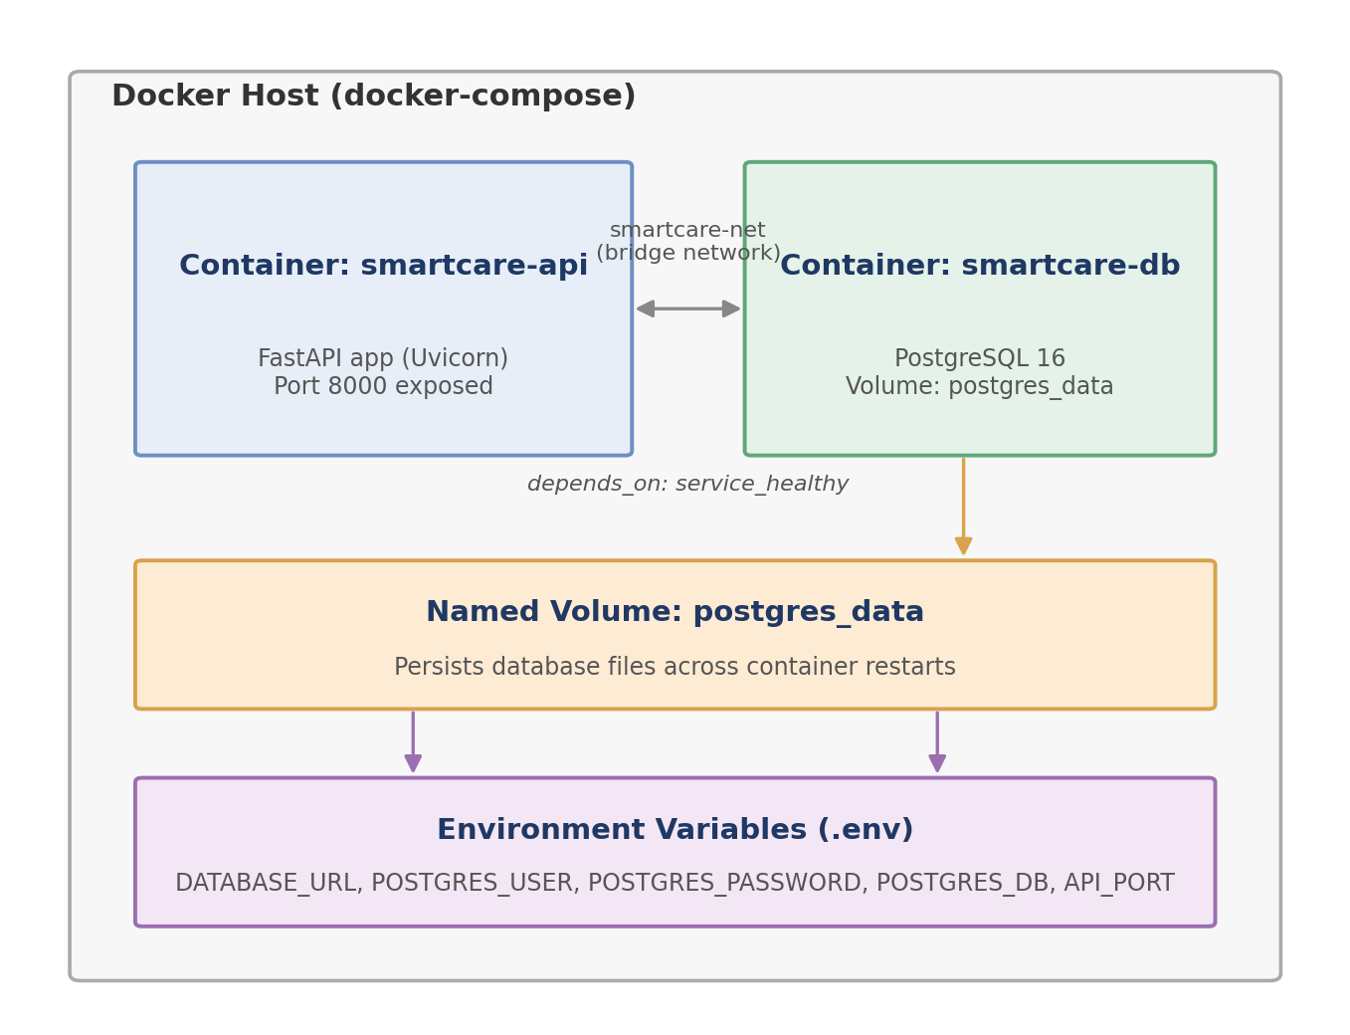
Figure 14: Docker Compose architecture — services, network, and volume

9.3 Services, Networking, Volumes, Environment Variables, and Dependencies
Services: api (the FastAPI application, built from the local Dockerfile) and db (PostgreSQL 16, pulled from Docker Hub) — two independently restartable containers defined in one file.
Networking: both services join the smartcare-net bridge network, so the API reaches the database using the hostname db rather than a hard-coded IP address; only the API's port is published to the host.
Volumes: a named volume, postgres_data, is mounted into the database container so table data persists across `docker compose down`/`up` cycles instead of being lost when the container is removed.
Environment variables: DATABASE_URL, POSTGRES_USER, POSTGRES_PASSWORD, and POSTGRES_DB are injected from a local .env file (based on .env.example) rather than hard-coded, keeping credentials out of version control.
Dependencies: depends_on with condition: service_healthy ensures the API container does not start until PostgreSQL's healthcheck (pg_isready) passes, avoiding connection errors on a cold start.
- Container Deployment and Testing

The commands below show the exact sequence used to build and run the application via Docker Compose. Because the assignment sandbox used to prepare this report has no Docker daemon available, the output shown is the expected, standard output for this Dockerfile/Compose configuration and is labelled accordingly — running `docker compose up --build` locally, as described in the README, will reproduce this sequence.
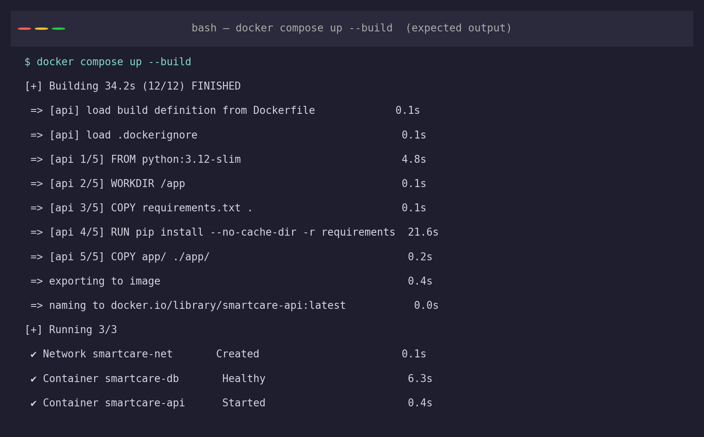
Figure 15: Expected output of `docker compose up --build`
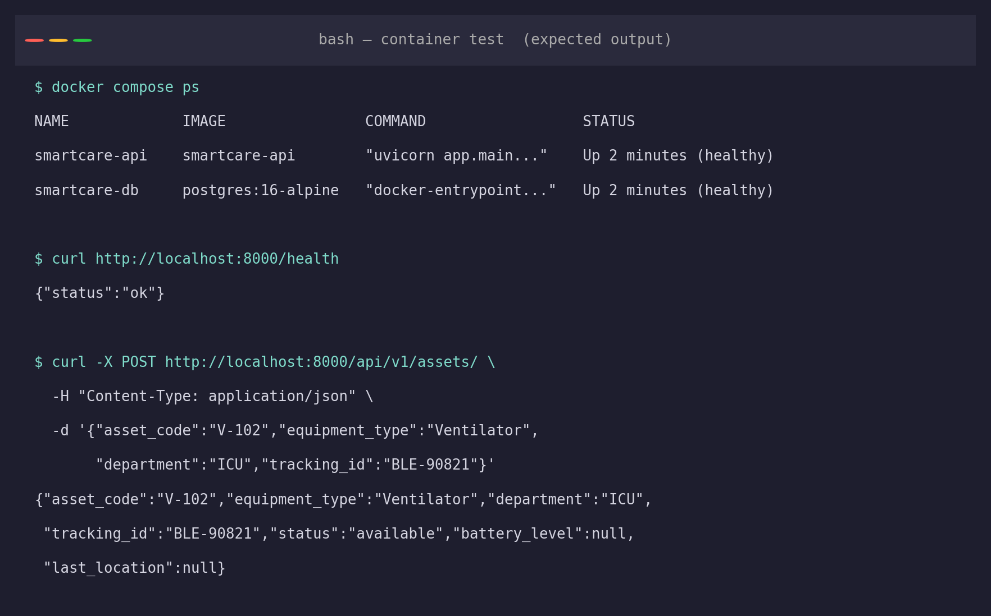
Figure 16: Expected container health check and API smoke test

10.1 Testing Procedure
- Run `docker compose ps` and confirm both containers report a healthy status.
- Call GET /health and confirm a 200 response with {"status": "ok"}.
- Call POST /api/v1/assets/ with a sample asset payload and confirm the record is created and returned with status "available".
- Call POST /api/v1/telemetry/telemetry with a battery_level below 15% for that tracking ID and confirm the response reports low_battery_alert: true and status "maintenance_required".
- Run the Pytest suite (`pytest`) inside the container or against a local virtual environment to confirm the automated tests pass.

11. Benefits of Git and Docker
Collaboration: feature branches let multiple contributors (or the same contributor working on multiple concerns) work in parallel without blocking each other, merging through develop only once each piece is complete.
Version management: annotated tags (v1.0.0, v1.0.1) and a readable commit history give an exact, auditable record of what changed and when — essential for a system touching hospital operations.
Portability: the Docker image runs identically on a developer laptop, a CI runner, or a hospital's on-premises server, removing environment-specific bugs.
Deployment: a single `docker compose up` command starts the entire stack (API + database) with correct networking and startup ordering already encoded in docker-compose.yml.
Scalability: because the API is stateless and containerized, additional API replicas can be added behind a load balancer without changing the application code; the database remains the one stateful component with a persistent volume.
Maintainability: the branching model isolates risk — a hotfix can reach production through its own short path without dragging in unrelated, half-finished develop work — while the Dockerfile's layer caching keeps rebuilds fast as the codebase grows.

12. Challenges and Improvements

12.1 Challenges Encountered
- Merge conflicts on shared documentation files (README.md) when two feature branches edited the same section concurrently — resolved manually as shown in Section 5.2, but avoidable with clearer section ownership.
- Choosing a safe low-battery threshold required a follow-up hotfix once the initial 20% cutoff proved too aggressive in practice — illustrating why staging/testing environments matter before values like this reach production.
- Coordinating environment variables safely: ensuring .env is never committed while still keeping .env.example current for every teammate required discipline enforced through .gitignore rather than tooling.
- No local Docker daemon was available in the environment used to prepare this report, so container build/run evidence in Section 10 is documented as expected output rather than a captured live screenshot; the student should reproduce these steps locally to capture first-hand screenshots for final submission.

12.2 Possible Improvements and Future Enhancements
- Add a CI pipeline (e.g., GitHub Actions) that runs the Pytest suite and builds the Docker image automatically on every pull request into develop.
- Introduce Alembic migrations for schema changes instead of relying on SQLAlchemy's implicit table creation, so schema evolution is explicit and versioned.
- Add branch-protection rules on main and develop requiring passing CI checks and at least one review before merge.
- Extend docker-compose.yml with a reverse proxy (e.g., Nginx or Traefik) and TLS termination for a production-realistic deployment.

